Name: Pranali Sonawane
Subject: CCNA
Lab – Router on a Stick(ROAS) :
First we have taken 1 Router, 1 switches and 5 pc’s. Pcs connected using straight through cable and switch are connected Router using straight through cable.

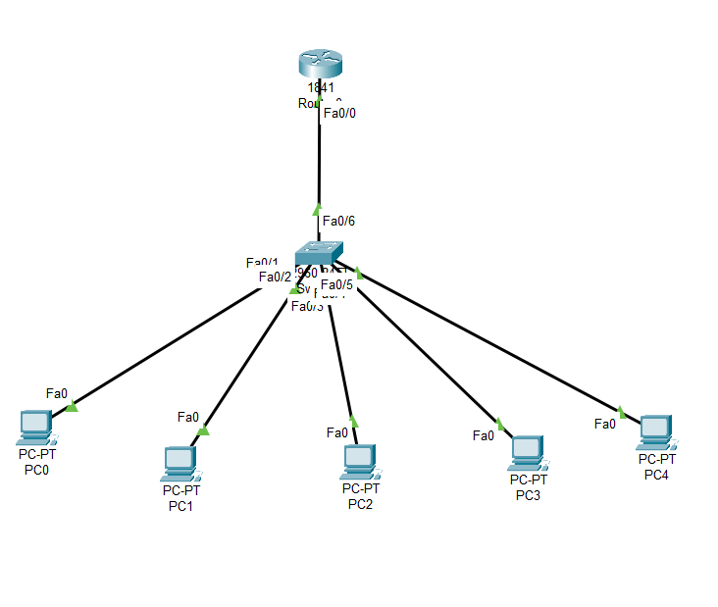
Configure PCs
- PC0:
  - IPv4 Address: 10.0.0.3
  - Subnet Mask: 255.0.0.0
  - Default Gateway: 10.0.0.1
- PC1:
  - IPv4 Address: 20.0.0.3
  - Subnet Mask: 255.0.0.0
  - Default Gateway: 20.0.0.1
- PC2:
  - IPv4 Address: 30.0.0.3
  - Subnet Mask: 255.0.0.0
  - Default Gateway: 30.0.0.1
- PC3:
  - IPv4 Address: 40.0.0.3
  - Subnet Mask: 255.0.0.0
  - Default Gateway: 40.0.0.1
- PC4:
  - IPv4 Address: 50.0.0.3
  - Subnet Mask: 255.0.0.0
  - Default Gateway: 50.0.0.1

Open Switch 0 – CLI prompt then type following commands
Switch>enable
Switch#config terminal
For VLAN 10 :
Switch (config)#vlan 10
Switch (config-vlan)# name CCNA
Switch (config-vlan)#exit

Switch (config)#interface fastEthernet 0/1
Switch (config-if)#switchport mode access
Switch (config-if)#switchport access vlan 10
Switch (config-if)#exit

For VLAN 20 :
Switch (config)#vlan 20
Switch (config-vlan)#name MCSA
Switch (config-vlan)#exit

Switch (config)#interface fastEthernet 0/2
Switch (config-if)#switchport mode access
Switch (config-if)#switchport access vlan 20
Switch(config-if)#exit

For VLAN 30 :
Switch (config)#vlan 30
Switch (config-vlan)#name Linux
Switch (config-vlan)#exit

Switch (config)#interface fastEthernet 0/3
Switch (config-if)#switchport mode access
Switch (config-if)#switchport access vlan 30
Switch(config-if)#exit

For VLAN 40 :
Switch (config)#vlan 40
Switch (config-vlan)#name AWS
Switch (config-vlan)#exit

Switch (config)#interface fastEthernet 0/4
Switch (config-if)#switchport mode access
Switch (config-if)#switchport access vlan 40
Switch(config-if)#exit

For VLAN 50 :
Switch (config)#vlan 50
Switch (config-vlan)#name Azure
Switch (config-vlan)#exit

Switch (config)#interface fastEthernet 0/5
Switch (config-if)#switchport mode access
Switch (config-if)#switchport access vlan 50
Switch(config-if)#exit

To make interface common use Trunk :
Switch (config)#interface fastEthernet 0/6
Switch (config-if)#switchport mode trunk

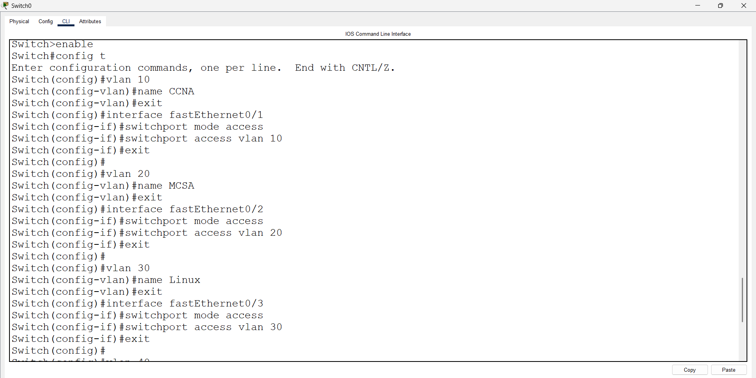

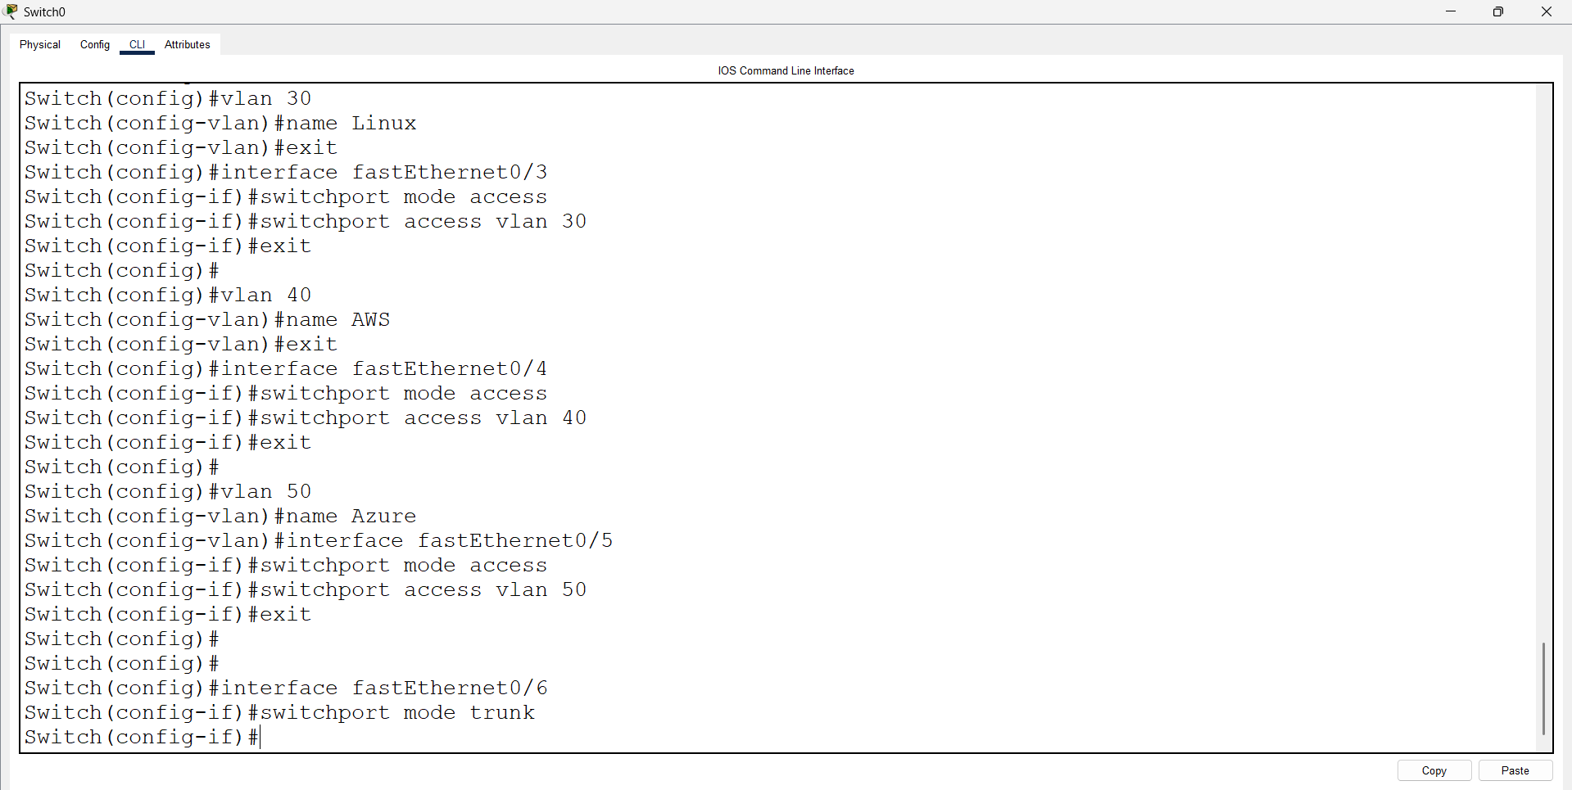

Open Router 0 – CLI prompt then type following commands
Router>enable
Router#configure terminal
Router(config)# interface fastEthernet 0/0
Router(config-if)#no shutdown
Router(config)# exit
Router(config)# interface fastEthernet 0/0.10

Router(config-subif)# encapsulation dot1Q 10
Router(config-subif)# ip address 10.0.0.1 255.0.0.0
Router(config-subif)# exit

Router(config)# interface fastEthernet 0/0.20
Router(config-subif)# encapsulation dot1Q 20
Router(config-subif)# ip address 20.0.0.1 255.0.0.0
Router(config-subif)# exit

Router(config)# interface fastEthernet 0/0.30
Router(config-subif)# encapsulation dot1Q 30
Router(config-subif)# ip address 30.0.0.1 255.0.0.0
Router(config-subif)# exit

Router(config)# interface fastEthernet 0/0.40
Router(config-subif)# encapsulation dot1Q 40
Router(config-subif)# ip address 40.0.0.1 255.0.0.0
Router(config-subif)# exit

Router(config)# interface fastEthernet 0/0.50
Router(config-subif)# encapsulation dot1Q 50
Router(config-subif)# ip address 50.0.0.1 255.0.0.0
Router(config-subif)# exit

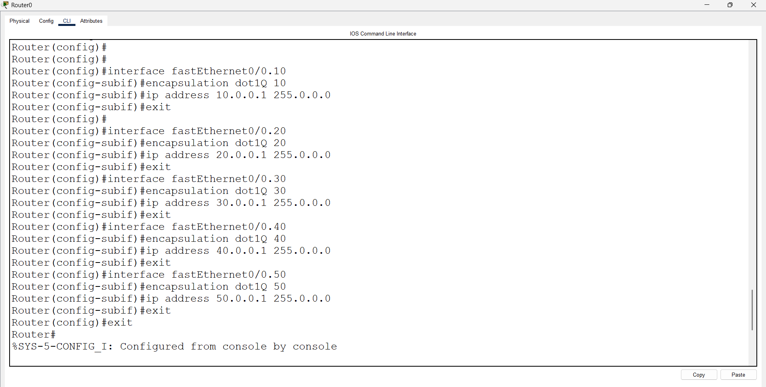
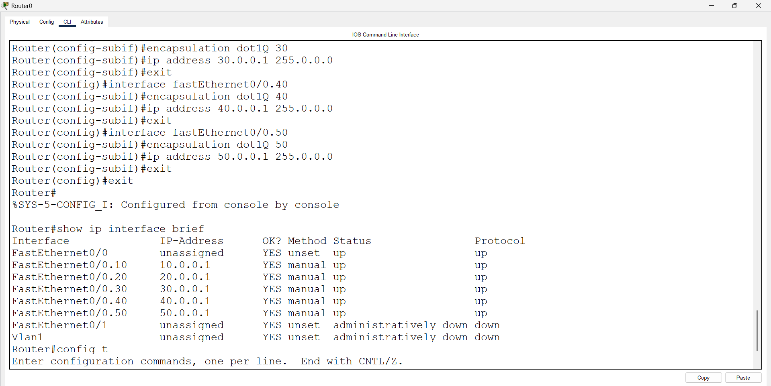

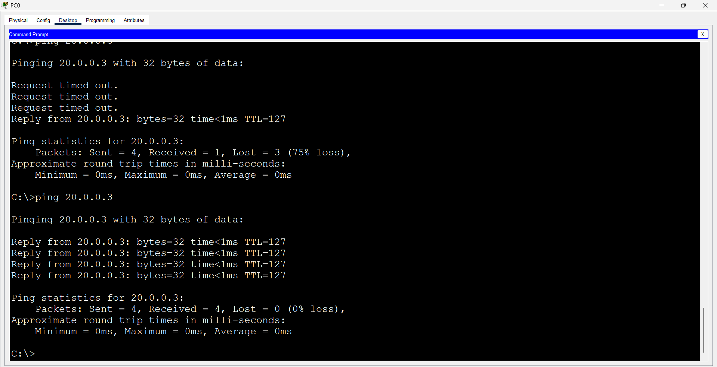

First we have taken 1 Router, 2 switches and 4 pc’s. Pcs connected Switch using straight through cable and switch are connected Router using straight through cable.

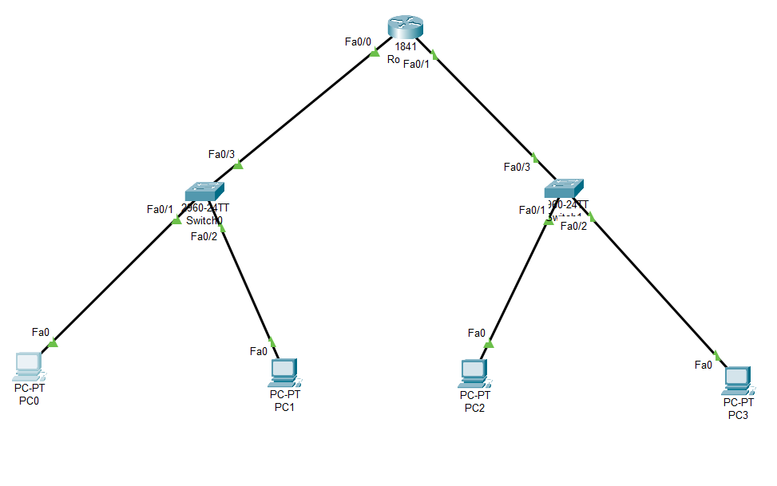

Configure PCs
- PC0:
  - IPv4 Address: 10.0.0.3
  - Subnet Mask: 255.0.0.0
  - Default Gateway: 10.0.0.1
- PC1:
  - IPv4 Address: 20.0.0.3
  - Subnet Mask: 255.0.0.0
  - Default Gateway: 20.0.0.1
- PC2:
  - IPv4 Address: 30.0.0.3
  - Subnet Mask: 255.0.0.0
  - Default Gateway: 30.0.0.1
- PC3:
  - IPv4 Address: 40.0.0.3
  - Subnet Mask: 255.0.0.0
  - Default Gateway: 40.0.0.1

Open Switch 0 – CLI prompt then type following commands
Switch>enable
Switch#config terminal
For VLAN 10 :
Switch (config)#vlan 10
Switch (config-vlan)# name CCNA
Switch (config-vlan)#exit

Switch (config)#interface fastEthernet 0/1
Switch (config-if)#switchport mode access
Switch (config-if)#switchport access vlan 10
Switch (config-if)#exit

For VLAN 20 :
Switch (config)#vlan 20
Switch (config-vlan)#name MCSA
Switch (config-vlan)#exit

Switch (config)#interface fastEthernet 0/2
Switch (config-if)#switchport mode access
Switch (config-if)#switchport access vlan 20
Switch(config-if)#exit

To make interface common use Trunk :
Switch (config)#interface fastEthernet 0/3
Switch (config-if)#switchport mode trunk

Open Switch 1 – CLI prompt then type following commands
For VLAN 30 :
Switch (config)#vlan 30
Switch (config-vlan)#name Linux
Switch (config-vlan)#exit

Switch (config)#interface fastEthernet 0/3
Switch (config-if)#switchport mode access
Switch (config-if)#switchport access vlan 30
Switch(config-if)#exit

For VLAN 40 :
Switch (config)#vlan 40
Switch (config-vlan)#name AWS
Switch (config-vlan)#exit

Switch (config)#interface fastEthernet 0/4
Switch (config-if)#switchport mode access
Switch (config-if)#switchport access vlan 40
Switch(config-if)#exit

To make interface common use Trunk :
Switch (config)#interface fastEthernet 0/3
Switch (config-if)#switchport mode trunk

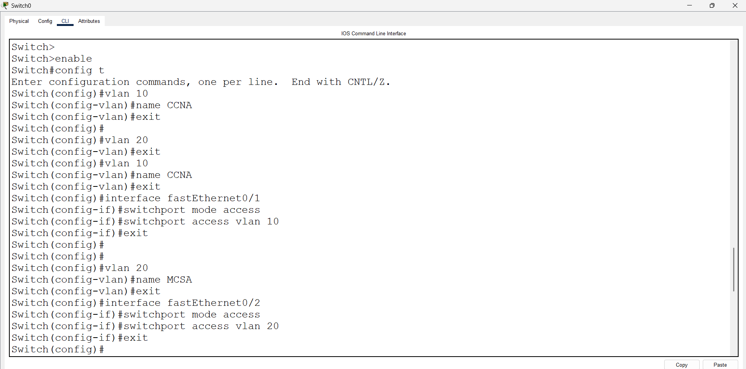
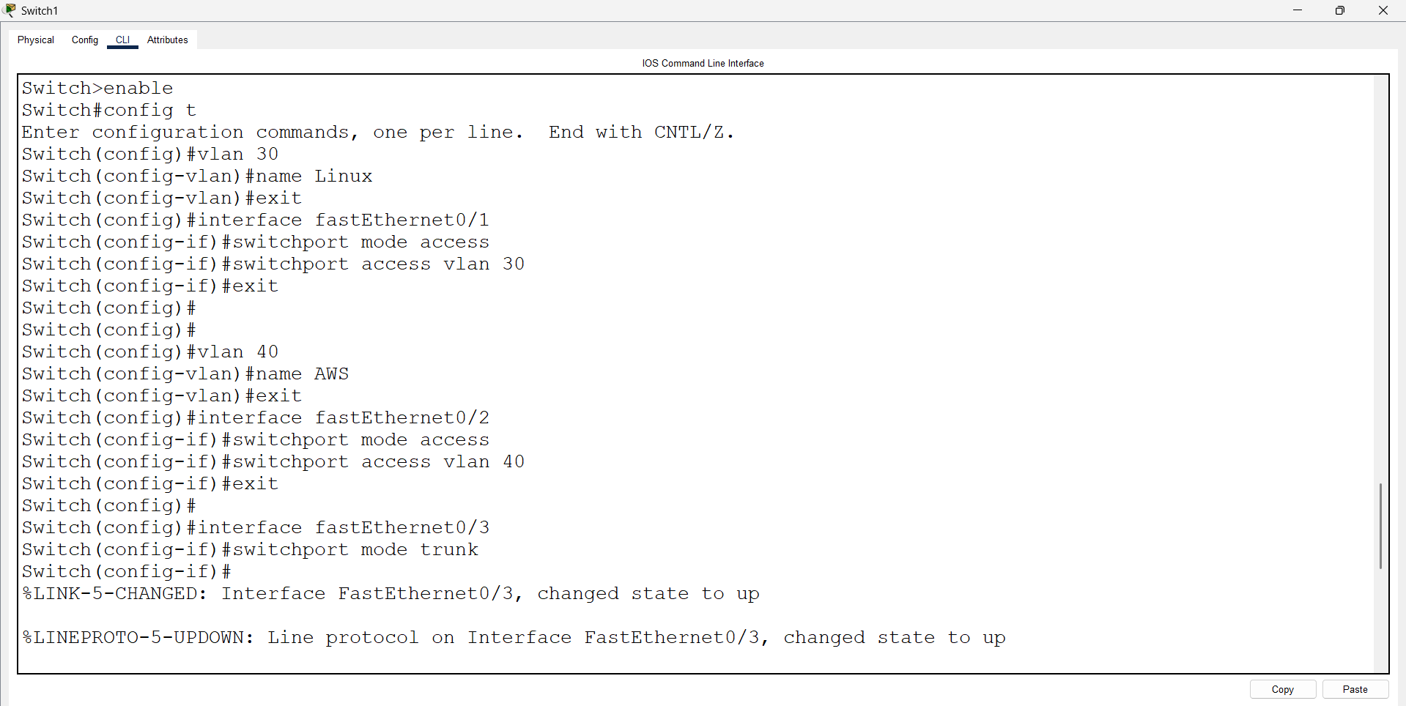
Open Router 0 – CLI prompt then type following commands
Router>enable
Router#configure terminal
Router(config)# interface fastEthernet 0/0
Router(config-if)#no shutdown
Router(config)# exit
Router(config)# interface fastEthernet 0/0.10
Router(config-subif)# encapsulation dot1Q 10
Router(config-subif)# ip address 10.0.0.1 255.0.0.0
Router(config-subif)# exit

Router(config)# interface fastEthernet 0/0.20
Router(config-subif)# encapsulation dot1Q 20
Router(config-subif)# ip address 20.0.0.1 255.0.0.0
Router(config-subif)# exit

Router(config)# interface fastEthernet 0/1.30
Router(config-subif)# encapsulation dot1Q 30
Router(config-subif)# ip address 30.0.0.1 255.0.0.0
Router(config-subif)# exit

Router(config)# interface fastEthernet 0/1.40
Router(config-subif)# encapsulation dot1Q 40
Router(config-subif)# ip address 40.0.0.1 255.0.0.0
Router(config-subif)# exit
